**SMART CITY INFRASTRUCTURE**

**Submitted By**

*Muhammad Hassan Sohail 22K-8704*

**Group Members**

*Muhammad Hassan Sohail 22K-8704*

*Ahmed Arshad 22K-8725*

Department of Computer Science  
National University of Computer & Emerging Sciences

1. **Motivation**

With the rapid urbanization and increased population in metropolitan areas, the need for efficient, secure, and automated infrastructure has become imperative. This project aims to design and simulate a smart city infrastructure that integrates advanced networking concepts and IoT devices to enhance the quality of life, resource management, and security of urban dwellers.

1. **Overview**

**2.1 Significance of the Project**

The project is significant due to its applicability in modern urban development. It provides a practical implementation of various networking concepts such as IP addressing, VLAN, OSPF, subnetting, and DHCP, alongside IoT and wireless technologies. Academically, it offers a platform to understand real-world applications of computer networks.

**2.2 Description of the Project**

The Smart City Infrastructure project simulates a citywide network connecting smart homes, management offices, departments, and service providers. It includes DHCP, DNS, FTP, Email, IoT, VLAN, and routing protocols to manage network services efficiently. Different clusters such as Smart Homes, Management Offices, and City Departments are interlinked with redundancy to ensure constant communication and data flow.

**2.3 Background of the Project**

Numerous research and practical implementations have explored smart cities. References such as Cisco Smart+Connected Communities, IEEE publications on smart infrastructure, and simulation tools like Cisco Packet Tracer provide foundational knowledge. Concepts from computer networking courses and IoT system design were also pivotal.

**2.4 Project Category**

Product-based Project

1. **Features / Scope / Modules**

· *Independent Smart Homes*  
Configured with HomeGateway (SSID: HomeGateway, IP: 192.168.25.1), equipped with IoT devices controlled via set conditions.

· *Management Office Integration*  
Interlinked with Parking, Energy, and ISP clusters. Provides DNS, DHCP, Email, HTTP/HTTPS, and IoT services.

· *DHCP Centralized Configuration*  
Dynamic IP allocation from server site to various clusters (Parking, Energy, Departments).

· *Static Configuration for Server Site*  
Manages DNS, FTP, Email, and DHCP services with IP range 192.168.102.64/28.

· *VLAN and Inter-VLAN Routing*  
Implemented across switches and multilayer devices to ensure segmented and secure communication.

· *OSPF and Default Routing*  
Enabled on routers and multilayer switches to ensure optimal path routing and redundancy.

· *Wireless Communication via Cell Towers*  
All mobile devices connect to the nearest cell tower based on the ISP.

1. **Project Planning**

* Phase 1: Research & Requirement Gathering (Week 1-2)
* Phase 2: Network Topology Design (Week 3-4)
* Phase 3: Configuration & Implementation (Week 5-8)
* Phase 4: Testing & Troubleshooting (Week 9-10)
* Phase 5: Documentation & Final Review (Week 11-12)

*Responsibilities:*

* Muhammad Hassan Sohail: Topology design, DHCP & IoT configuration
* Ahmed Arshad: VLAN setup, routing protocols, documentation

1. **Project Feasibility**

*· Technical Feasibility*  
The project is feasible with current simulation tools like Cisco Packet Tracer. IoT and networking technologies used are widely available.

*· Economic Feasibility*  
Minimal hardware/software costs due to use of simulators. High cost-efficiency with significant academic value.

· *Schedule Feasibility*  
Planned within 3-month academic timeline. Buffer included for testing and documentation.

1. **Hardware and Software Requirements**

*Hardware:*

* Computers with standard configurations
* Internet access

*Software:*

* Cisco Packet Tracer
* Any supporting text editor for documentation

1. **Diagrammatic Representation of the Overall System**

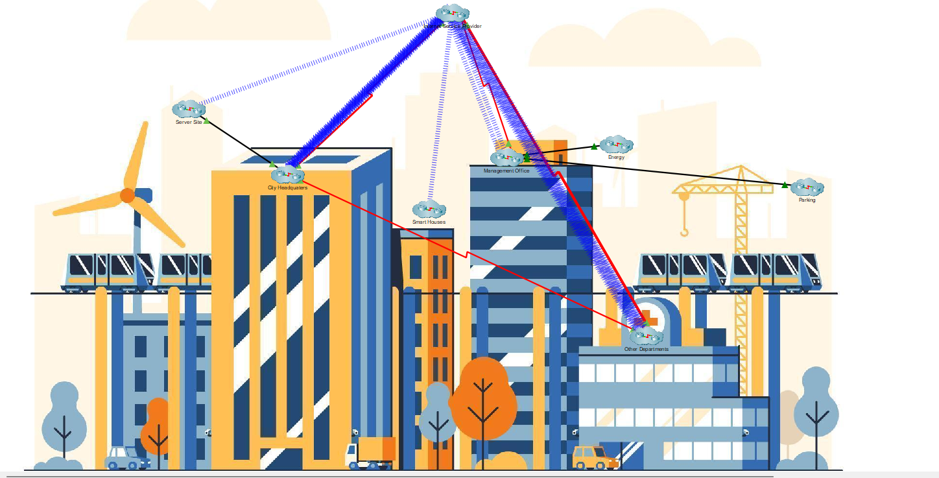

1. **References**

*[1] Cisco Systems, "Smart+Connected Communities,"* [*https://www.cisco.com/c/en/us/solutions/industries/smart-connected-communities.html*](https://www.cisco.com/c/en/us/solutions/industries/smart-connected-communities.html)

*[2] Tanenbaum, A. S., & Wetherall, D. J. (2011). Computer Networks (5th ed.). Pearson.*

*[3] IEEE Smart Cities Initiative,* [*https://smartcities.ieee.org/*](https://smartcities.ieee.org/)

*[4] Packet Tracer Simulation Examples and Documentation*

*[5] IoT and Smart City Concepts, Research Articles on IEEE Xplore*

**Working Demo Screenshots:**

